PRACTICAL 13: Excel Student Result Management

Aim
To analyze student marks using Excel tools.

Objectives
•To apply Excel formulas
•To create charts

Materials Required
•MS Excel

Procedure
1. Enter student data
Input students’ names, marks, and other required details into the spreadsheet.

2. Use Flash Fill
Apply Flash Fill to automatically complete patterns such as separating names or formatting data.

3. Replace incorrect values
dentify errors and use Find & Replace or manual correction to fix inaccurate entries.

4. Calculate pass/fail using IF
Create an IF formula to determine whether each student passes or fails based on their score.

5. Use COUNTIF and AVERAGE
Apply COUNTIF to count specific results and AVERAGE to compute the class’s mean score.

6. Create charts
Generate visual charts to represent student performance trends or score distributions.

7. Apply conditional formatting
Use color-based formatting to highlight important values, such as loscores or top performers.
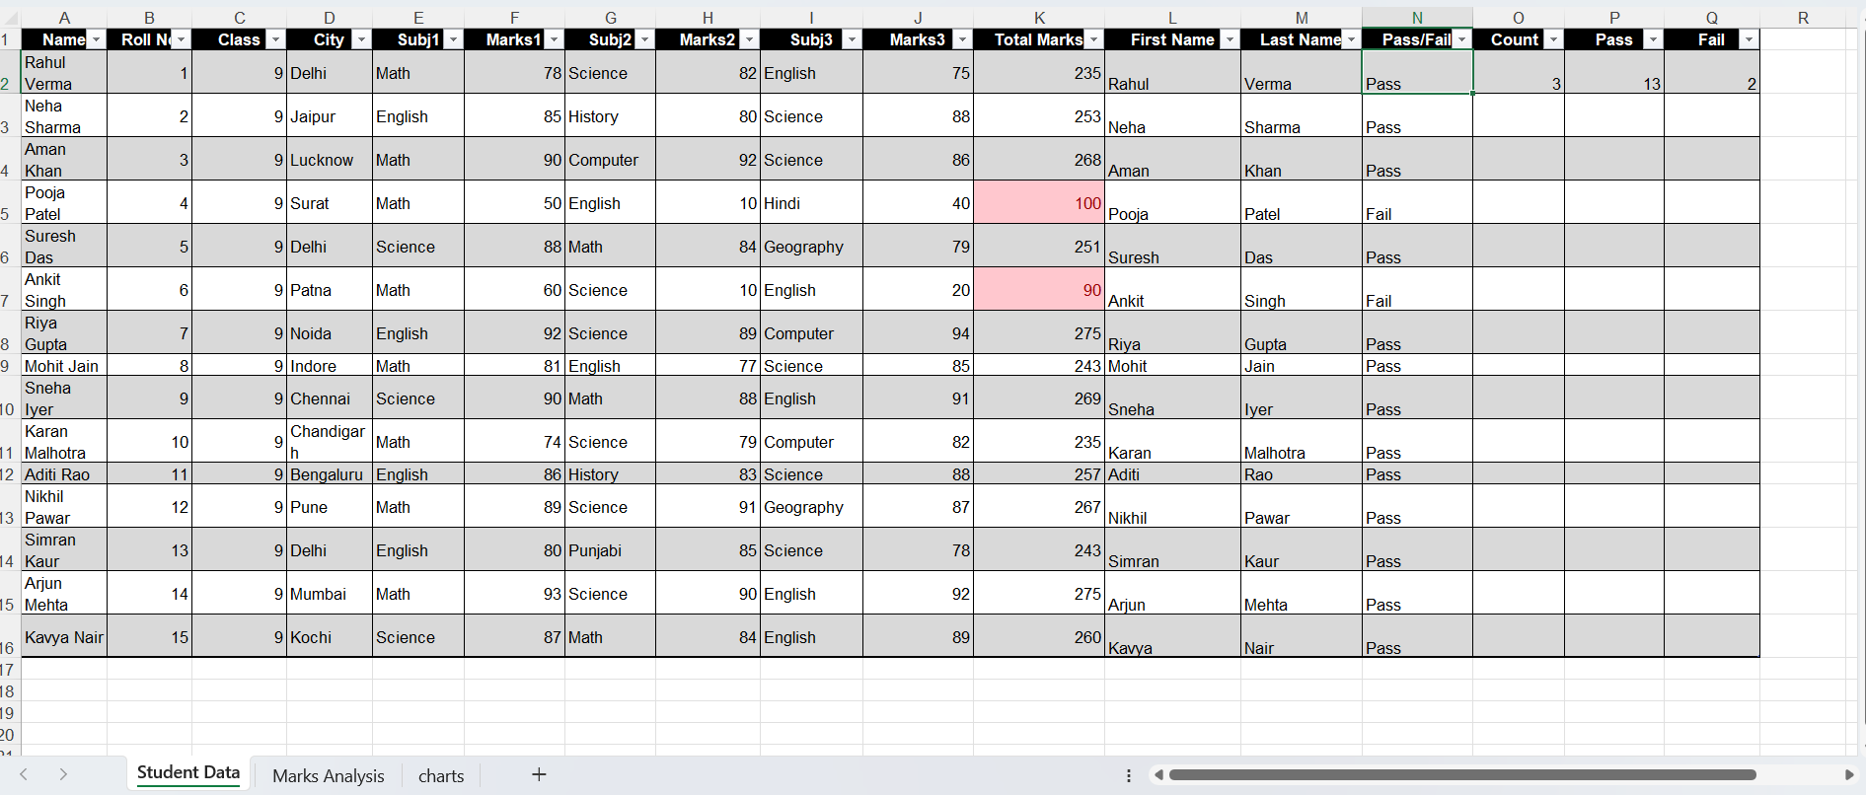
Output:
